ELEC 2210 LABORATORY REPORT COVER PAGE
Complete and attach this page to the front of your lab report.

Meeting # 001 EXPERIMENT 2: Simulation of Logic Circuits
Title of Lab Experiment

Student Name: Howard Jacob, A
Name (Last, First, MI)

Student Email: JAH0147
AU 7-character username

GTA: It does not say in Syllabus
Name of your GTA

Section you are enrolled in: (Circle One): 1 2 3 4 5 6 7 8

Date experiment performed (dd / mm / yy): 17/08/20

Date report submitted: (dd / mm / yy): 24/8/20

If you performed this experiment at a time other than your regularly scheduled section meeting:

Section # of the section you sat in on (Circle One): 1 2 3 4 5 6 7 8 Makeup

Name of the GTA who supervised your work: None

I hereby certify that the contents of this report are true and complete to the best of my ability. The lab work was performed by me exclusively, and this report was written by me exclusively.

Jacob Howard 8/24/20
Student signature Date signed

ELEC-2210
Digital Electronics

FROM: Jacob Howard
TO: TA
DATE: 8/24/20
LAB SECTION: 001 (Tuesday, 1:00pm-2:50 pm)

EXPERIMENT 2:
Simulation of Logic Circuits

Introduction
This week’s lab was completely online. We were to perform all tasks on a personal computer and email any Tas for questions. We were asks to design and sketch a circuit diagram of a 3-bit synchronous binary counter using only three JK flip flops and two 2-input AND gates. We sketched this for our prelab and we used our design in this lab.

Steps 1-2
This lab had a total of 4 steps. In steps 1 through 3 we were to take our prelab design and put it into Multisim. Multisim is a circuit design tool with many features that can help you design and test circuits in a virtual environment.
In the first step, we were introduced to Multisim. There was a 10 min tutorial to get us accustom to Multisim and the tools we can use within the software. Multisim comes with many different tools that make it very useful for circuit design.
Step 2 is where we use our prelab circuit to design a virtual circuit in Multisim. The circuit is a 3 bit binary counter. The objective is to design a circuit that can count from 000 to 111 and export the output to a hexadecimal digital display. I found that this step challenging because it depended strictly on our ability to design a circuit. I had a some trouble trying to set it up properly but in the end I believe I was able to make the circuit work. The circuit design I made can be seen in Figure 1.
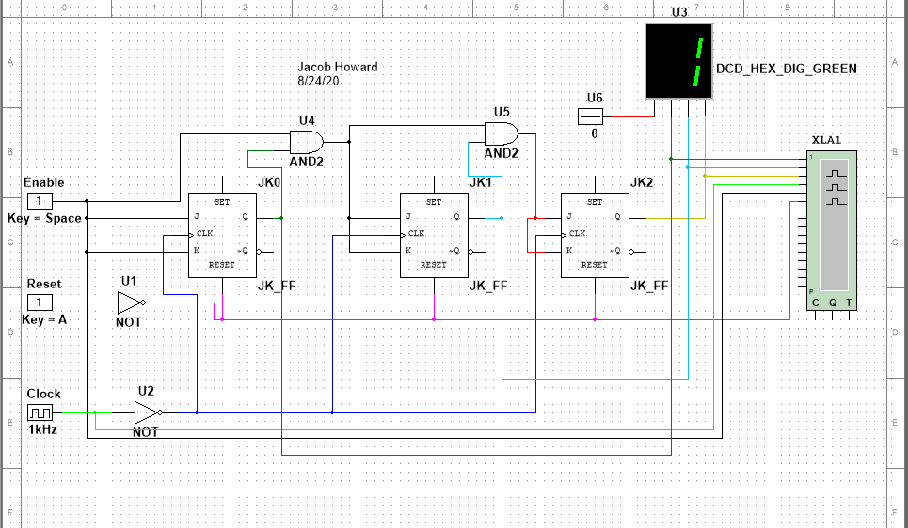
Figure 1

Steps 3-4
Tin step 3, we did something similar to steps 1 and 2, but for this binary counter, we were given the circuit design to start with. Because we were given a circuit to start with, this task was much more simple than steps 1 and 2. We were just required to simply copy the design into Multisim and make sure everything was set up properly. The given circuit is shown below in Figure 2.
This binary counter is based on the 74193 chip. By using the 74193, a virtual version of a Digital Writer, and a logic analyzer connected properly, the circuit was able to get all the functions of the binary counter to work. The RESET function sets the value to 0. After every UP pulse, the number shown in the digital display would increase from the previous number. The circuit design I made is shown in Figure 3.
In Step 4, we were just required to submit our Multisim files to our TA. In our case, we are just to upload everything to canvas.
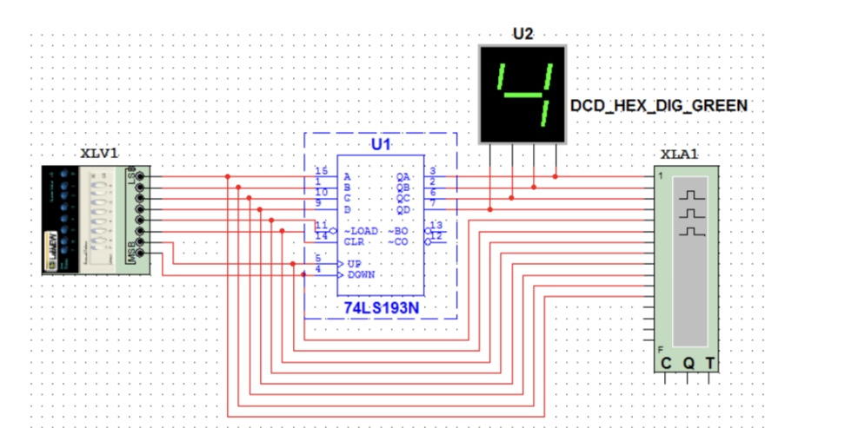
Figure 1
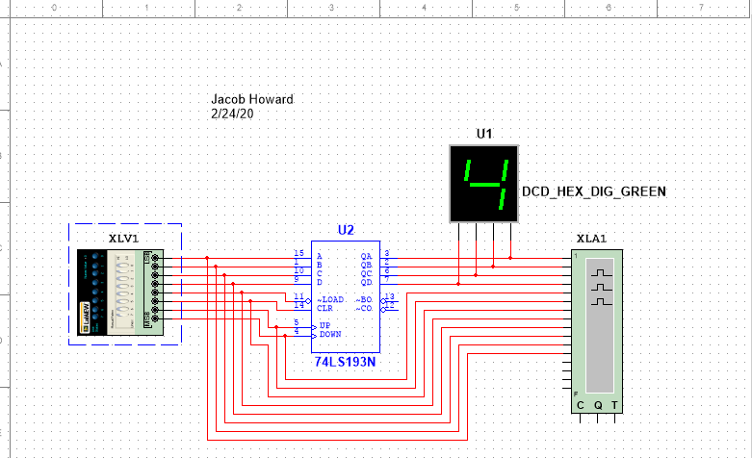
Figure 3

Conclusion
This experiment was a good way of showing how we can use Multisim to create various virtual circuits. Multisim is a great tool for anyone creating circuits and it has many different uses. Multisim can be used as a safe and simple way to design and test circuits and is very convenient. I did struggle with the design of the 3-bit binary counter and do wish to learn more about them to better understand how they work. This could help me better create circuits in the future. This lab was a learning experience for me as I have not had DLC in a while.

